**REACT**

**Hands On -2**

Create a React Application named “officespacerentalapp” which uses React JSX to create elements, attributes and renders DOM to display the page.

* Create an element to display the heading of the page.
* Attribute to display the image of the office space
* Create an object of office to display the details like Name, Rent and Address.
* Create a list of Object and loop through the office space item to display more data.
* To apply Css, Display the color of the Rent in Red if it’s below 60000 and in Green if it’s above 60000.

App.css

.textRed {

color: red;

font-weight: bold;

}

.textGreen {

color: green;

font-weight: bold;

}

img {

margin: 20px 0;

}

h1, h3 {

font-family: Arial, sans-serif;

}

App.js

import React from 'react';

import './App.css';

import officeImage from './office.jpg'; // Place an image named office.jpg in src folder

function App() {

const element = "Office Space";

const jsxatt = <img src={officeImage} width="25%" height="25%" alt="Office Space" />;

const officeList = [

{ Name: "DBS", Rent: 50000, Address: "Chennai" },

{ Name: "Regus", Rent: 65000, Address: "Bangalore" },

{ Name: "Cowrks", Rent: 55000, Address: "Hyderabad" },

{ Name: "SmartWorks", Rent: 70000, Address: "Mumbai" }

];

return (

<div>

<h1><b>{element} , at Affordable Range</b></h1>

{

officeList.map((item, index) => {

let colors = [];

if (item.Rent <= 60000) {

colors.push("textRed");

} else {

colors.push("textGreen");

}

return (

<div key={index}>

{jsxatt}

<h1><b>Name: {item.Name}</b></h1>

<h3 className={colors.join(" ")}>Rent: Rs. {item.Rent}</h3>

<h3>Address: {item.Address}</h3>

<hr />

</div>

);

})

}

</div>

);}

export default App;

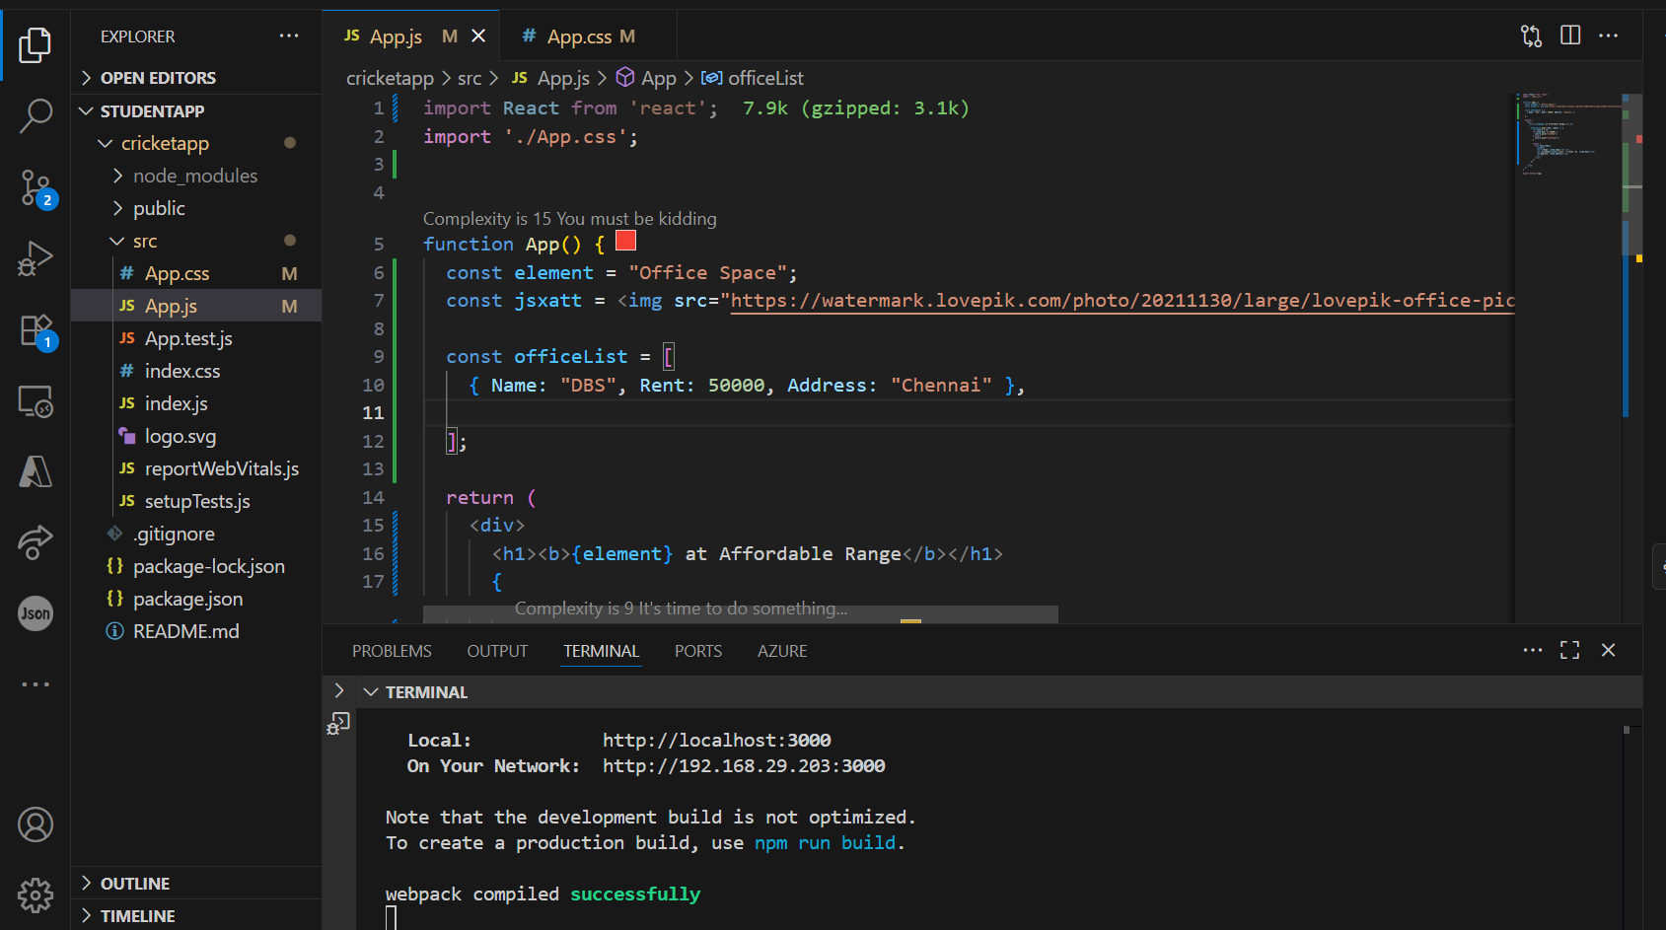

**Output:**

